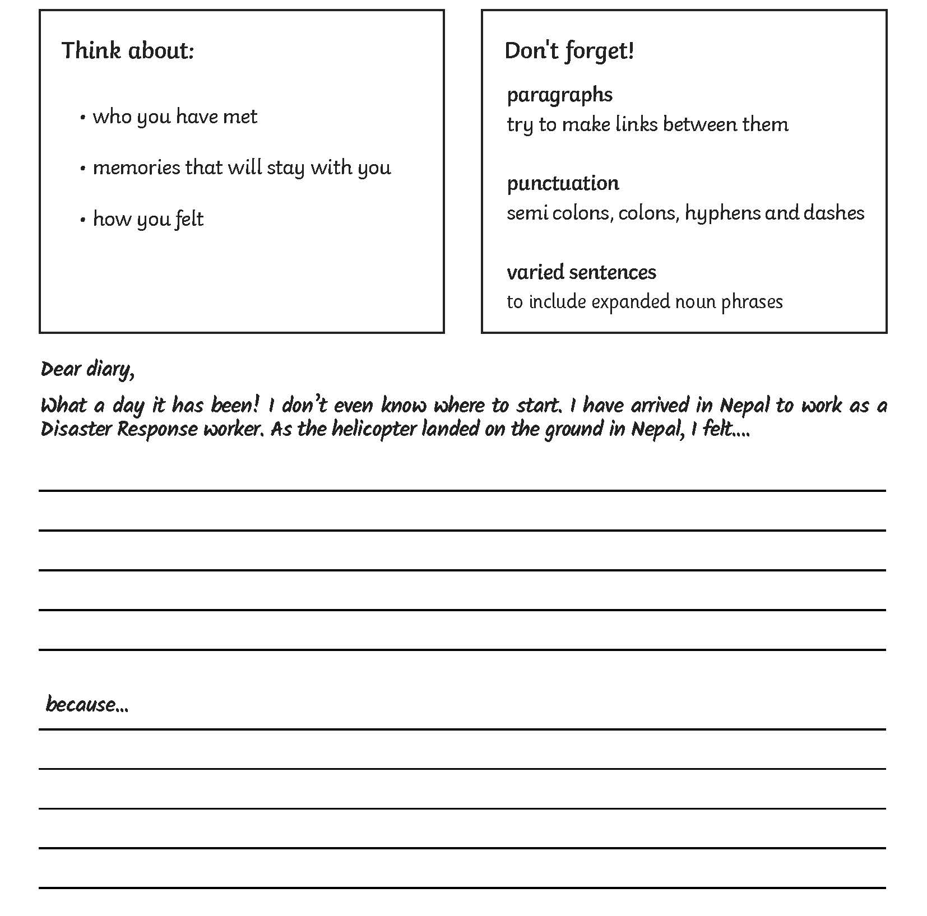
A recount from a character’s point of view.
Don’t Forget:

Capital Letters and Full Stops

Describing words

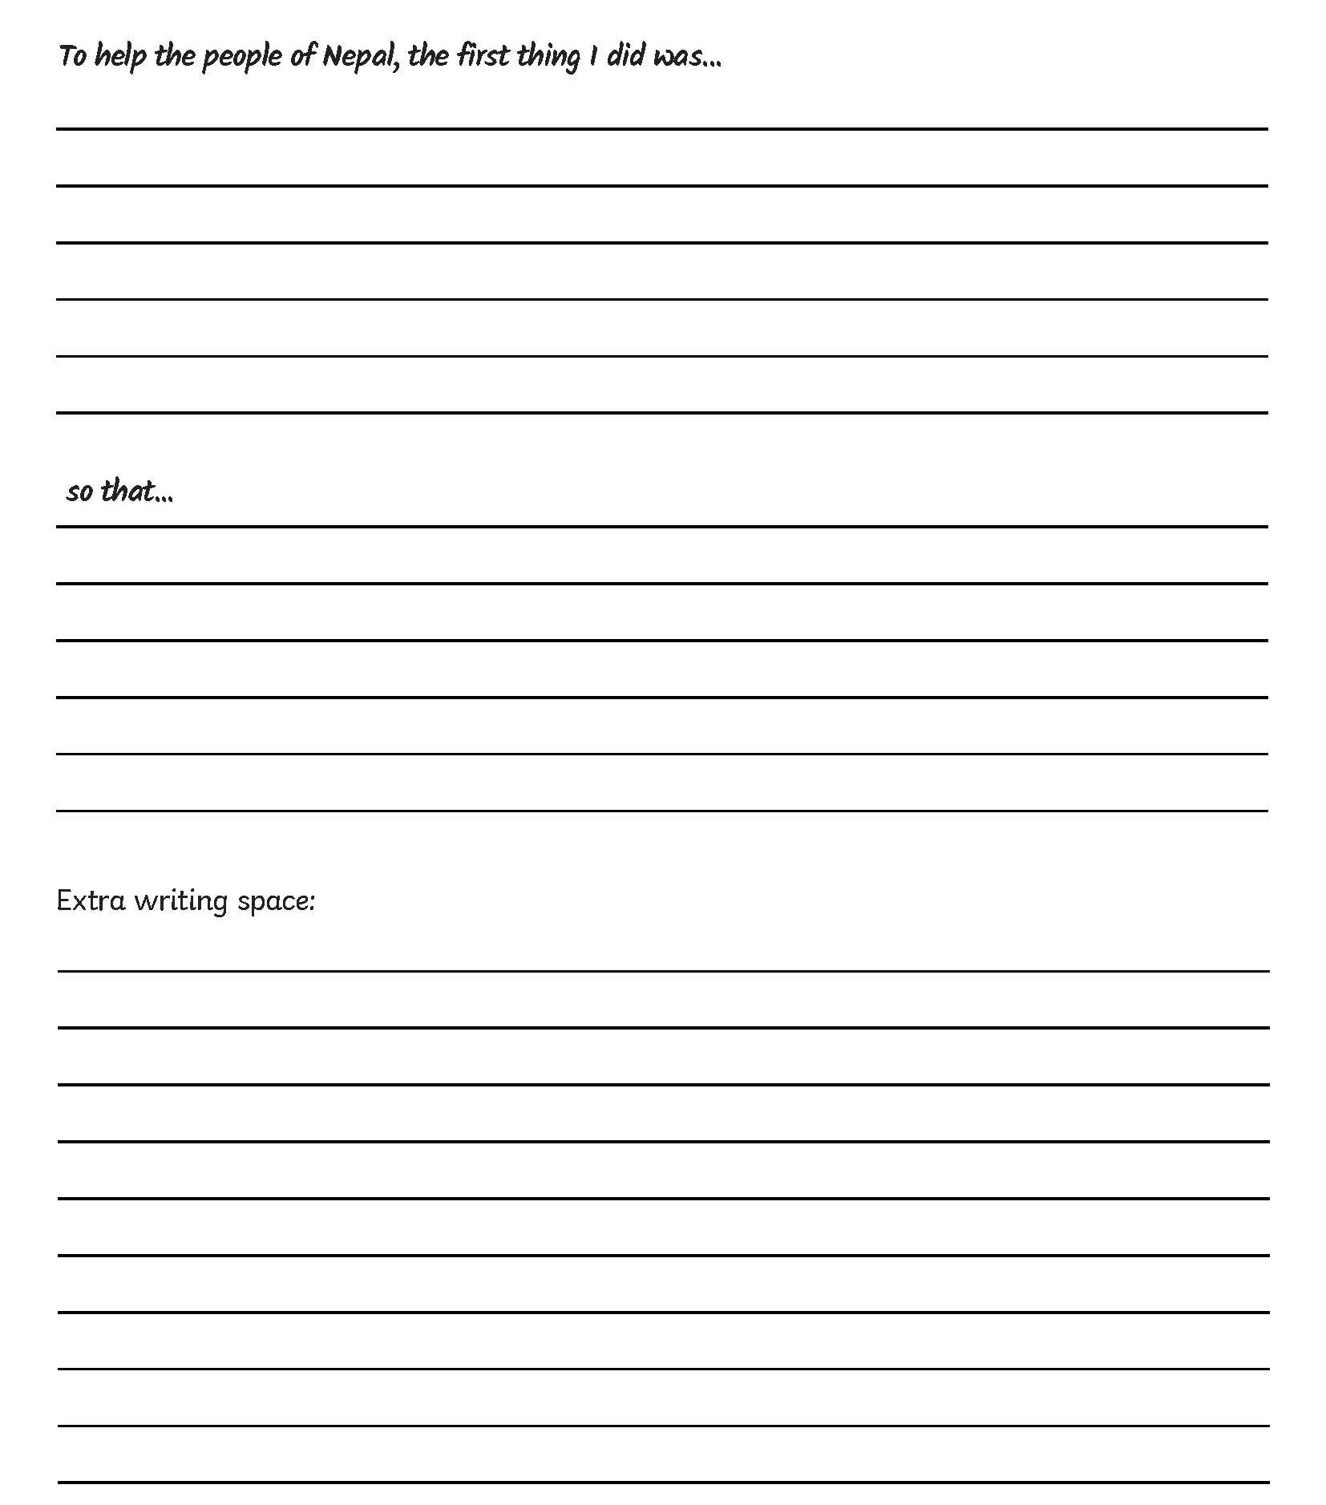

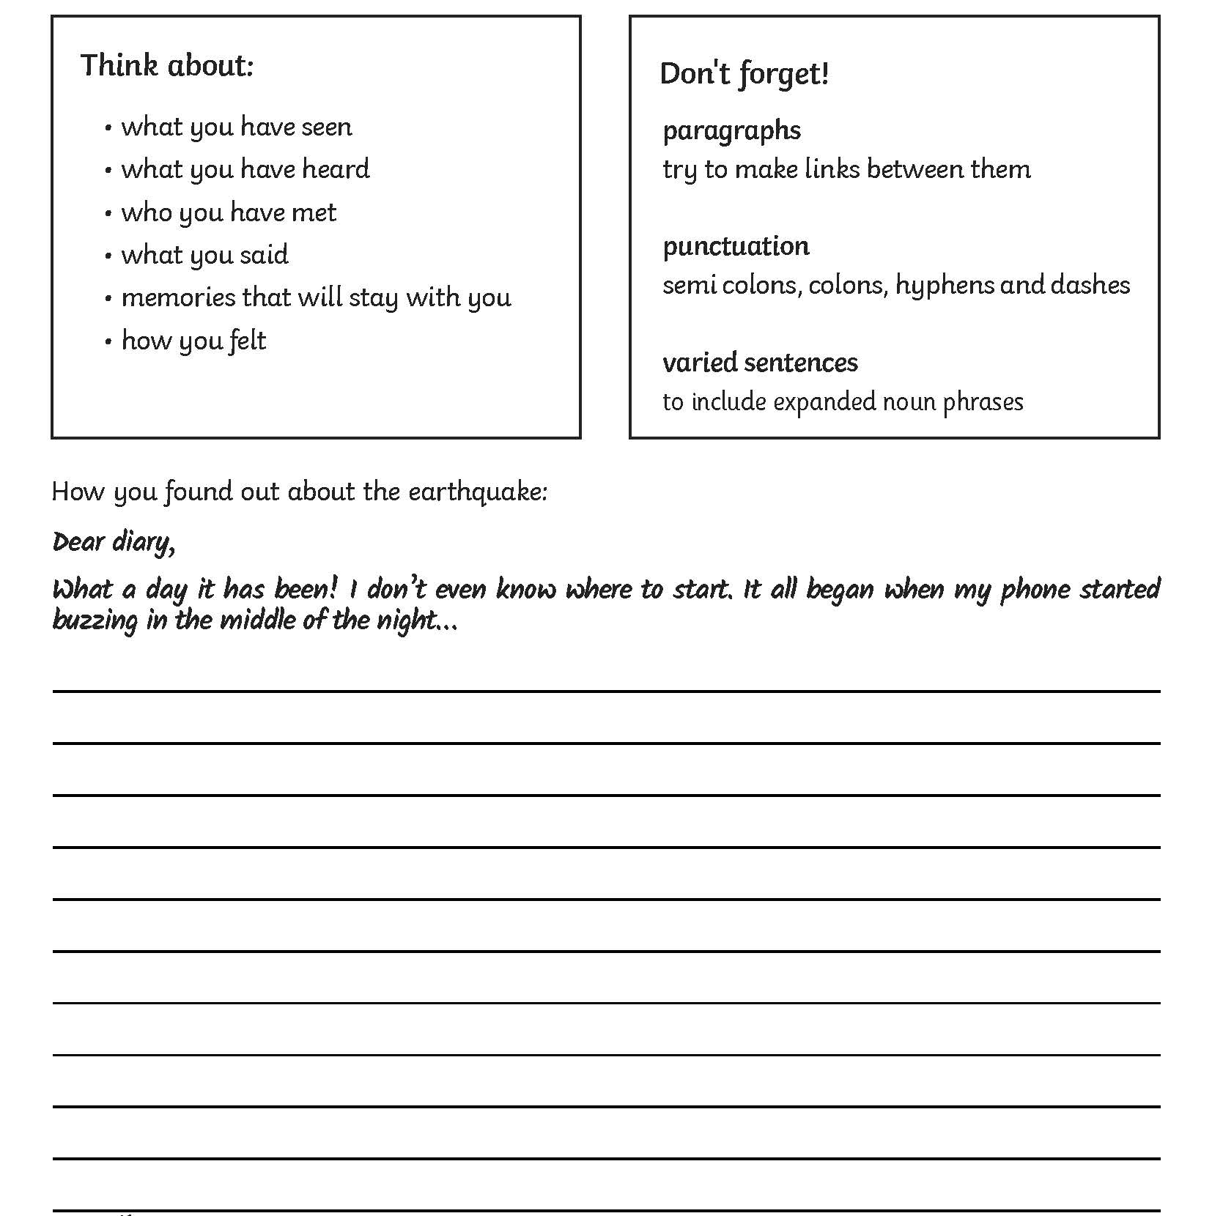
A recount from a character’s point of view.
Don’t Forget:
Expanded Noun Phrases
Give details to help the reader imagine the vents for themselves.
Punctuation
Include brackets, dashes or commas to give extra information.
Use exclamation marks for emphasis.
A recount from a character’s point of view.
Don’t Forget:
Expanded Noun Phrases
Give details to help the reader imagine the vents for themselves.
Punctuation
Include brackets, dashes or commas to give extra information. Use colons and semi-colons to link ideas.
Paragraphs
Try to link your paragraphs by referring to earlier parts of your text.

