Dear Y2 Parents
If anyone is looking for something extra for maths you might like to try some lessons on the following link.
I recommend starting from Summer Term Week 2 (beginning 27th April) but if you like the format you can always go back and try previous lessons for revision.
https://whiterosemaths.com/homelearning/year-2/
This is today’s maths challenge: Questions 1, 2 and 3 are for Year 2s.

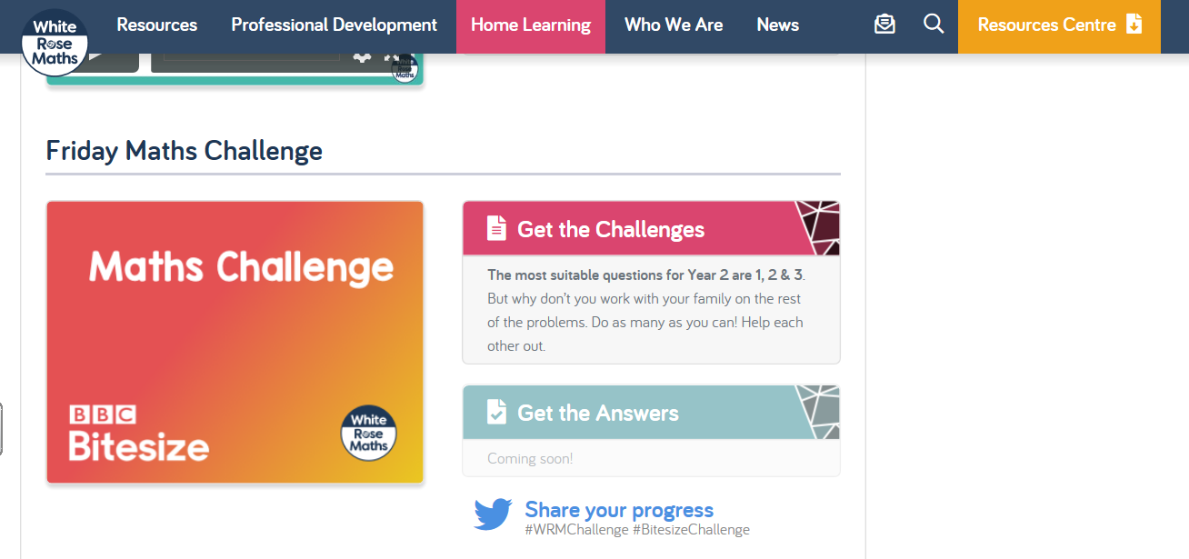

Please let me know your thoughts if you try this site out.
Best wishes
Gill Beecroft

